WISDOMWHERE GUIDE
How to Enter an Event

- Logon using your admin credentials.
- Under Mainenance select Event.
Then click Add New.
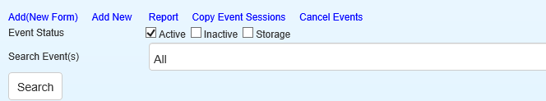

Bold Items are required fields. See explanations below.
*Italics – This indicates required fields that are pre-populated and that you skip.

Event Name – Name your event. I recommend listing your school name and the school year at the beginning or end of the name, especially if the event is for your staff only. For example: Google Updates – Jefferson 2021-2022.

Event Narrative – Enter a description of the PD event.

*Sort Order – This is set to zero. No change needed.

Category – Use the dropdown arrow and select Professional Development.

Target Audience – Enter your audience members. For example: Teachers, Teacher Assistants, 3rd grade teachers, all math teachers, etc.

Learner Outcomes – List the measurable outcomes for participants upon completion of the PD event.

Contact Name – Use the dropdown box and select your name.

Confirmation Message – For Registrant Screen Conf., select Event Screen Confirmation. For Registrant Email Conf., select Event Email Registration Confirmation.

*Auto Confirm Registrant – This field is pre-populated. No change needed.

*Allow Registrant to enroll in multiple sessions – This field is pre-populated. Typically no change is needed. On RARE occassions this setting may need to be changed if you decide to build an event with multiple days/times with separate sessions for each time (instead of listing all the days/times within one session.).

Allow Registrant to un-register – Click in the box and then enter 1 or 0 in the box after the word until. You can choose any number of days you like. I recommend giving teachers the ability to un-register up to the day of the event.

*Current Status – This field is pre-populated. No change needed.

Resgistration Restricted To – Please do not use these fields.

Click Submit Approval – After you click Submit, you may be taken to a screen that says “You are not allowed to view this page.” Click Menu to return to the main Wisdomwhere menu. After your event request has been reivewed and processed, you will receive an email that your event has been approved. Then you can build the sessions.

